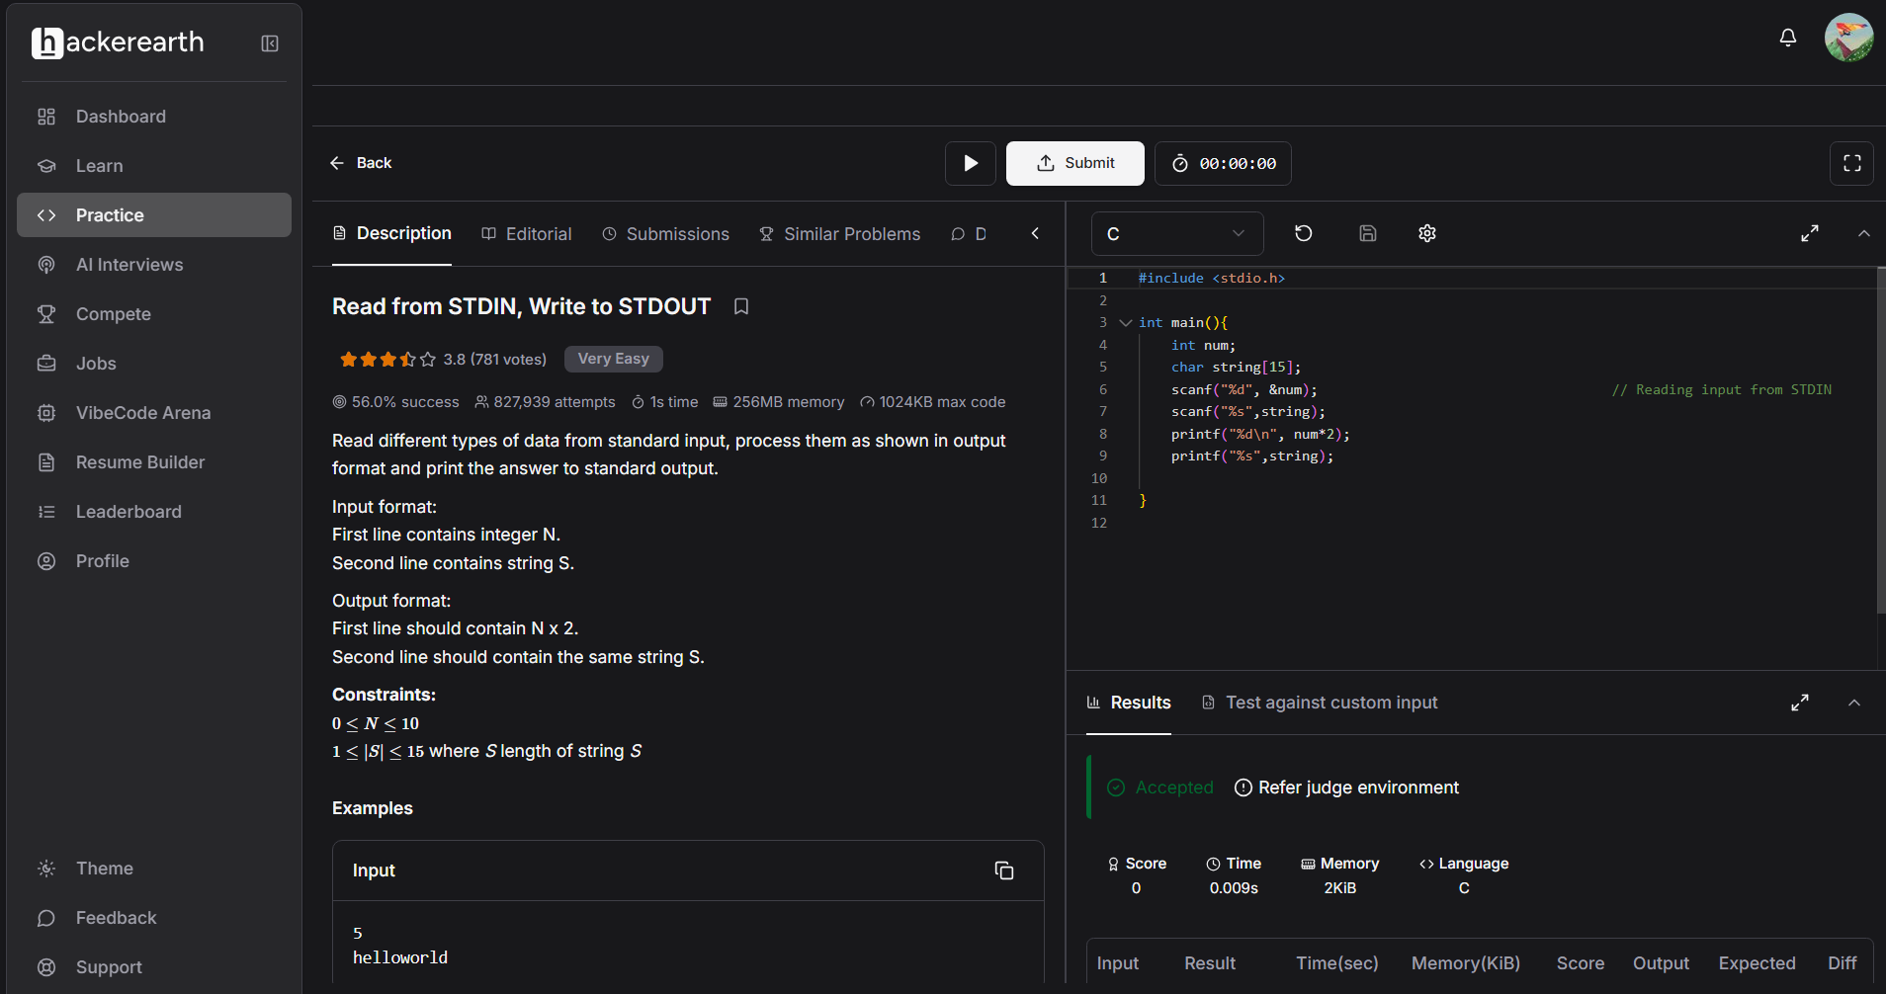
#include <stdio.h>

int main(){
int num;
char string[15];
scanf("%d", &num); // Reading input from STDIN
scanf("%s",string);
printf("%d\n", num*2);
printf("%s",string);

}

